[1]

Electromyography Controller for eGame using Signal Processing/Conditioning and LabVIEW

Aaron Luna*,* *Student Member, IEEE*

*Abstract*— Electromyography (EMG) is a method of measuring muscle activity in relation to a particular muscle being stimulated by contraction. The uniqueness of this method of measuring muscle activity is that it allows for different clinical and biomedical applications such as biomechanics, motor control, and physical therapy. However, it is not just limited to medical applications, it can be used to control many other surrounding devices. This study uses EMG signal processing in tandem with LabVIEW to create an EMG controller that allows for an eGame to be played on a laptop without pressing any of the arrow keys. Several electrodes are placed on the brachii biceps of both a right and left arm to control an eGame. In other words, given a specific combination of muscle contractions, that is, an EMG signal, a control signal is generated which then triggers a specific arrow key on the laptop. A set of data is collected which shows the filtered data, and digitized data of both EMG signals developed. Additionally, the directional button being activated given a specific combination of EMG signals is shown. The result of this study shows that EMG signal processing is a viable method to measure muscle activity and use for various pressing and needed applications.

*Keywords*— *EMG signal, control signal, electrodes, signal processing*

# INTRODUCTION

Electromyography, more commonly known as, EMG, is method of quantifying muscle activity given a muscle contraction. As mentioned in the abstract, many doctors use this method of analysis to determine neuromuscular behavior of a patient. To conduct this analysis, surface electrodes are placed onto the skin, over a highly active muscle (such as a bicep), from which electrical activity is then recorded and displayed on an oscilloscope [1]. The signal obtained is known as an EMG signal. The EMG signal is abundant with information about muscle activity, that is, we want to analyze it. However, since EMG signals are too small of a signal to analyze and understand what is means, signal conditioning and processing are required. Signal conditioning is the process of amplifying, filtering, rectifying, and eliminating any noise there might be with a signal [2]. Signal processing is the process of taking the conditioned signal and converting it into a digital control signal for an application [3]. In this experiment, an EMG signal is first conditioned, then processed into a digital control signal that will then allow for an eGame to be played with the contraction of certain muscles.

# experiment

## Signal Conditioning

For the signal conditioning portion of the experiment, the analog signal is amplified, filtered, and rectified. This is done as the analog signal obtained from the surface electrodes are too small and need to be altered for MCU/PC requirements. In this case, the instrumentation amplifier, band-pass filter, and ADC conversion are used to condition the signal, respectively. A lab kit provided by the lab instructor is given to conduct this experiment. This lab kit has the necessary circuity to condition the signal. The following components described are on the lab kit. The instrumentation amplifier used in this experiment is an INA128. The ­V­in+ and Vin- inputs are connected to the two muscle inputs with the help of the surface electrodes. The V+ and V- are then connected to +5V and -5V, respectively. The reference node is connected to the referee electrode and to the ground. The total gain of the instrumentation amplifier and band pass filter combined is the product of both individual gains. In this case, it is This total gain helps to amplify the EMG signal. Fig. 1 shows the circuit diagram of the instrumentation amplifier INA128.

Figure 1. Instrumentation Amplifier INA128 on ESET 359 Lab Kit [4]

Thereafter, the bandpass filter (LM741) is then connected. This bandpass will have a high pass cutoff frequency of and a low pass cutoff frequency of . The bandpass filter will help to take the amplified EMG signal of the INA128 and restrict the range of frequencies between the high pass and low pass cutoff frequencies [5]. The final output signal is the output of the bandpass filter which is the unfiltered EMG signal. Additionally, the output of EMG1 is sent to AI1 of the MCU and the output of EMG2 is sent to AI2 of the MCU. This is so the conditioned EMG signals can be analyzed in LabVIEW. The final circuit connection for the EMG circuit is shown in Fig 2.

Figure 2. Circuit connection for EMG circuit.

## B. Signal Processing in LabVIEW

For the signal processing of the EMG signal, LabVIEW is used. The final front panel of the EMG controller VI is shown in Fig 3. The final block diagram showing the third sequence of the stacked sequence of the EMG controller VI is shown in Fig. 4.

Figure 3. Front panel of EMG controller VI in LabVIEW

Figure 4. Block Diagram showing the third sequence of the stacked sequence of EMG controller VI in LabVIEW

First, a serial communication and analog input VI is used to communicate with the MCU and lab kit using the LabVIEW VISA protocol. Additionally, this VI will receive and display an analog input given from the MCU. In this case, the analog input provided are the two EMG signals. The VI will allow for the VISA resource name and baud rate to be selected. The VISA resource name in this experiment is COM5 and the baud rate used is 115200. The knob allows users to select between a ready state, UART state and analog state. For this experiment, the knob is set at analog. Thereafter, the data conversion from string to numbers portion of the VI is used to grab the appropriate data from the MCU, that is, the EMG1 and EMG2 conditioned signals. This is then sent to an equation that converts the analog signal into a signal that makes sense. That is, it is converted by multiplying it with 5,125, the product of the voltage supplied and the maximum number of readings the MCU can send. Additional filters are applied to the conditioned EMG signals to complete their linear envelope [6]. A low pass filter is used to average and calculate the root-mean square to obtain the envelop of the signal. The enveloped EMG signal is used to generate the 2-bit control signal strategy. However, before that, additional digital filters are used so eliminate any noise and smooth the enveloped signals. The numerical control input of these digital filters are set at 0.99. The equation implemented for these digital filters are the following:

The S1 variable is the value from the previous loop, that is, the updated filtered enveloped signal. The variable S2 is the filtered enveloped signal coming from the output of the low pass filter. The variable a controls the degree of smoothness of the signal, that is, it controls the noise. This is done for both EMG signals, that is, for the right and left arm. The updated filtered enveloped signals are sent to its corresponding shift registers and used to develop the 2-bit control signals. This portion of the VI will take in the filtered enveloped signals as inputs and convert them into a 2-bit (4 level) output based on a given threshold. The threshold designated the right EMG signal is 0.16, and 0.14, for the left EMG signal. Note that the EMG signals obtained were considerably small even after conditioning and processing them. To better understand the control strategy implemented, Table 1 is shown below.

TABLE I.

Control Strategy

|  |  |  |  |  |
| --- | --- | --- | --- | --- |
| Contraction of Arm(s) | EMG1 Digital Data | EMG2 Digital Data | Digital Control Signal | Arrow Key Activated |
| Left Arm Only | 1 | 0 | 1 | Left (37) |
| Right Arm Only | 0 | 2 | 2 | Right (38) |
| Right & Left Arm | 1 | 2 | 3 | Up (39) |
| Neither Right nor Left | 0 | 0 | 0 | Down (40) |

For the left arm EMG signal, given that if it is less than the threshold than the output of the logic operator will result in a 0, or 1, if it is greater than the threshold. For the right arm EMG signal, if it is less than the threshold than the output of the logic operator is 0, or 2, if it is greater than the threshold. Thereafter, the output of the logical operator of both the right and left EMG signals are added to create a 2-bit control strategy shown in Table 1. Given the summation of the resulting digital output of both EMG signals, then an arrow key is activated. To activate an arrow key, a subVI and case structure are used in tandem. The subVI provided by the lab instructor is for pressing keys programmatically on the keyboard. Fig. 5 shows an example of how the keyboard subVI is used. The output of the summation block (the resulting summing digital output of both EMG signals) is sent to the summation block, that selects a given case based on the 2-bit control output. For example, as shown in Fig 5., when the 2-bit control signal is 3, then a constant of 39 is inputted into the keyboard subVI to activate the up arrow key press. This process is repeated for the remaining arrow keys. For when the 2-bit control signal is 0, then a constant of 40 is inputted into the keyboard subVI to activate the down arrow key press. For when the 2-bit control signal is 1, then a constant of 37 is inputted into the keyboard subVI to activate the left arrow key press. For when the 2-bit control signal is 2, then a constant of 38 is inputted into the keyboard subVI to activate the right arrow key press. The resulting 2-bit control signal is also sent into waveform chart to view what arrow key is activated; this is shown in the front panel in Fig. 3. The filtered and digitized right and left arm EMG signals are logged into an Excel file. Along with the summation of the resulting digital output of both the right and left EMG signal, and what directional button is activated.

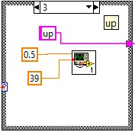

Figure 5. Example of how the keyboard subVI is used.

# results

## A. RESULTS

The results show that EMG controller works as intended and reliably. Fig. 6 shows the logged data of the EMG outputs for only the right arm contraction. As mentioned previously, the filtered EMG signals were considerably small, so they were multiplied by a constant of 100 to demonstrate how the data altered depending on the arm being contracted. In this logged data, the right arm is seen to be contracted as the right arm filtered data is larger than the left arm filtered data. Additionally, it is shown that as the right is being contracted and the left arm is relaxed, the digital output for the right arm 2 and 0 for the left arm, respectively. This results in a 2-bit control signal of 2. That means, case 2 of the case structure is selected and the right arrow is activated. Therefore, when playing an eGame online, when the right arm is contracted and left arm is relaxed, the Pac-man would go right. Fig. 7 shows the EMG controller being used to play Pac-man online with muscle contractions. In the figure, the person is shown to contract both arms, meaning that the control signal is 3, that is, the up-arrow key is activated. To iterate, this is based on the control strategy developed that is shown in Table 1. The EMG controller worked successfully as all contractions activated properly given the control strategy implemented in LabVIEW.

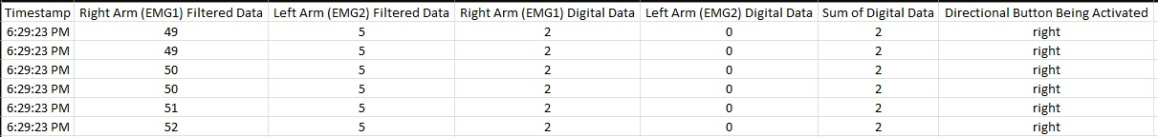

Figure 6. Logged data of the EMG Outputs (Right arm contraction is only shown here)

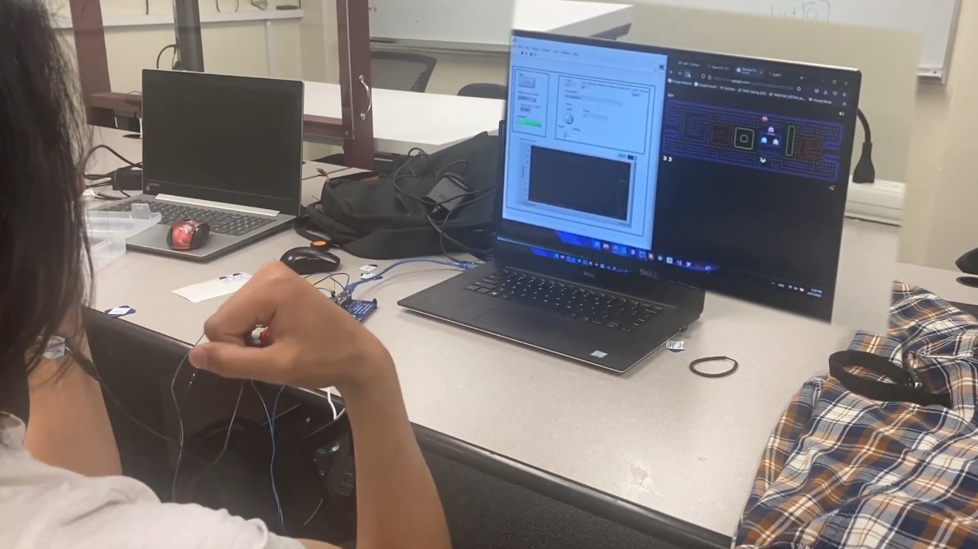

Figure 7. EMG controller used to play an eGame (Pac-man)

# Conclusion

The application of electromyography allows for a myriad of different types of applications. This experiment proves that with the appropriate signal conditioning and processing, electromyography controlled based applications are possible. In this case, it is seen how an EMG controller can allow for an eGame to be played online via simple contractions. These simple contractions translate to certain digital outputs which are then used to create a control strategy. This control strategy is used to output a certain behavior, that is, in this experiment, given a combination of certain contractions an arrow key is activated which drives the eGame. This experiment shows that EMG controlled based applications are reliable and have a strong potential for a broader range of applications in the future. This includes control interfacing between a robotic prosthetic and a patient.

References

1. “Electromyography (EMG),” *Johns Hopkins Medicine*, 08-Aug-2021. [Online]. Available: https://www.hopkinsmedicine.org/health/treatment-tests-and-therapies/electromyography-emg. [Accessed: 28-Apr-2022].
2. J. R. B. Garay, A. Singh, M. Martucci, H. D. H. Herrera, G. M. Calixto, S. I. Barbosa, and S. T. Kofuji, “An Electromyography Signal Conditioning Circuit Simulation Experience.” 2017.
3. “Signal Processing 101,” *IEEE Signal Processing Society*, 08-Jul-2021. [Online]. Available: https://signalprocessingsociety.org/our-story/signal-processing-101. [Accessed: 29-Apr-2022].
4. “INA128-HT,” *INA128-HT data sheet, product information and support | TI.com*. [Online]. Available: https://www.ti.com/product/INA128-HT. [Accessed: 29-Apr-2022].
5. “EMG Digital filter settings¶,” *EMG Digital Filter Settings - NES 1.72.7 documentation*. [Online]. Available: https://nes.readthedocs.io/en/latest/userguide/experiments/emgsettings/emgdigitalfilter.html. [Accessed: 01-May-2022].
6. W. Rose, “Electromyogram Analysis,” *Udel*, 24-Oct-2019. [Online]. Available: https://www1.udel.edu/biology/rosewc/kaap686/notes/EMG%20analysis.pdf. [Accessed: 01-Apr-2022].

1. *Research supported by Texas A&M University.

   Aaron Luna* is in the School of Multidisciplinary Engineering & Technology at Texas A&M University, College Station, TX 77840 USA (*corresponding author to provide e-mail: aaroniluna@tamu,edu).